**CH 6. Determining System Requirements**

* Describe(描述) options for designing and conducting interviews and develop a plan for conducting an interview to determine system requirements.
* Explain the advantages and pitfalls(隱患)of observing workers and analyzing business documents to determine system requirements.
* Explain how computing can provide support for requirements determination.
* Participate in and help plan a Joint Application Design session
* Use prototyping during requirements determination.
* Describe contemporary approaches to requirements determination.
* Understand how requirements determination techniques apply to the development of electronic commerce applications.

1. **Performing Requirements Determination**

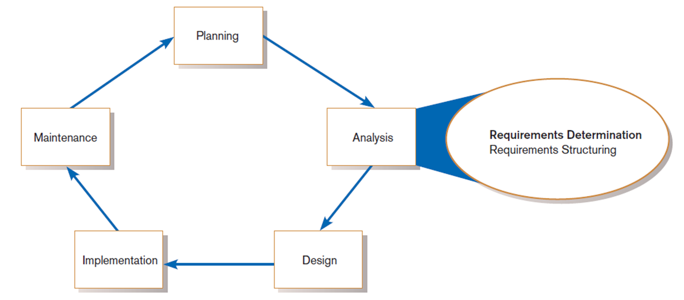

* + **Good Systems Analyst Characteristics:**
* Impertinence—question everything
* Impartiality—consider all issues to find the best organizational solution
* Relax constraints—assume anything is possible and eliminate the infeasible
* Attention to details—every fact must fit
* Reframing—challenge yourself to look at the organization in new ways

1. **Deliverables and Outcomes**
   * **Deliverables for Requirements Determination:**

* From interviews and observations
  + interview transcripts, observation notes, meeting minutes
* From existing written documents
  + mission and strategy statements, business forms, procedure manuals, job descriptions, training manuals, system documentation, flowcharts
* From computerized sources
  + Joint Application Design session results, CASE repositories, reports from existing systems, displays and reports from system prototype
* Additional components of an organization that are needed to be understood
  + The business objectives that drive what and how work is done
  + The information people need to do their job
  + The data handled within the organization to support the jobs
  + When, how, and by whom or what the data are moved, transformed, and stored
  + The sequence and other dependencies among different data-handling activities
  + The rules governing how data are handled and processed
  + Policies and guidelines that describe the nature of the business and the market and environment in which it operates
  + Key events affecting data values and when these events occur
* **Analysis paralysis**

1. **Traditional Methods for Determining Requirements**

* Interviewing and listening individuals
* One of the primary ways analysts gather information about an information systems project
* An interview guide is a document for developing, planning and conducting an interview.
* Guidelines for Effective Interviewing
  + Plan the interview.
  + Listen carefully and take notes (tape record if permitted).
  + Review notes within 48 hours.
  + Be neutral.
  + Seek diverse views.
  + Don’t phrase a question in a way that implies a right or wrong answer.
  + Don’t set expectations about the new system unless you know these will be deliverables.

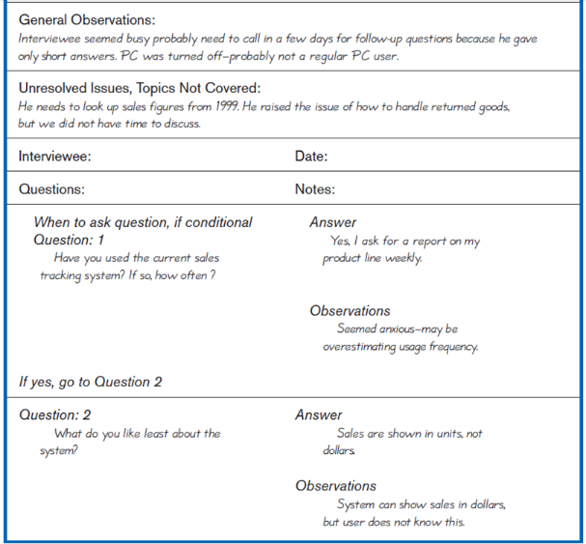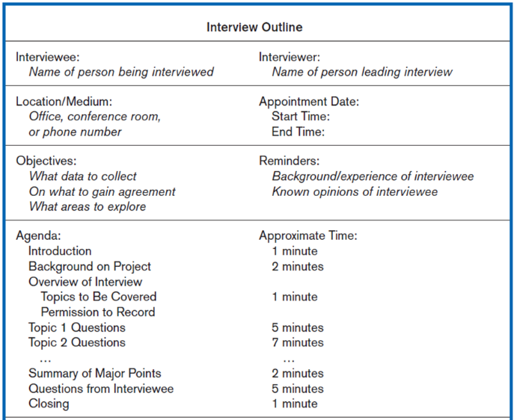

* Choosing Interview Questions

- Each question in an interview guide can include both verbal and non-verbal information.

* + Open-ended questions: questions that have no prespecified answers
  + Closed-ended questions: questions that ask those responding to choose from among a set of specified responses, e.g. True or false, Multiple choice
* Interviewing groups
* Drawbacks to individual interviews:
  + Contradictions and inconsistencies between interviewees
  + Follow-up discussions are time consuming
  + New interviews may reveal new questions that require additional interviews with those interviewed earlier
* Interviewing several key people together:

- Advantages

* + More effective use of time
  + Can hear agreements and disagreements at once
  + Opportunity for synergies

- Disadvantages

* + More difficult to schedule than individual interviews
* Nominal Group Technique (NGT)
  + A facilitated process that supports idea generation by groups
  + Used to complement group meetings or as part of JAD effort
* Directly observing workers
* Direct Observation
  + Watching users do their jobs
  + Used to obtain more firsthand and objective measures of employee interaction with information systems
  + Can cause people to change their normal operating behavior
  + Time-consuming and limited time to observe
* Analyzing procedures and other business documents
* Document Analysis
  + Review of existing business documents
  + Can give a historical and “formal” view of system requirements
* Types of information to be discovered:
  + Problems with existing system
  + Opportunity to meet new needs
  + Organizational direction
  + Titles and names of key individuals
  + Values of the organization or individuals who can help determine priorities for different capabilities desired by different users
  + Special information processing circumstances
  + Reasons for current system design
  + Data, rules for processing data, and principles by which the organization operates that must be enforced by the IS
* Useful document: Written work procedure
  + For an individual or work group
  + Describes how a particular job or task is performed
  + 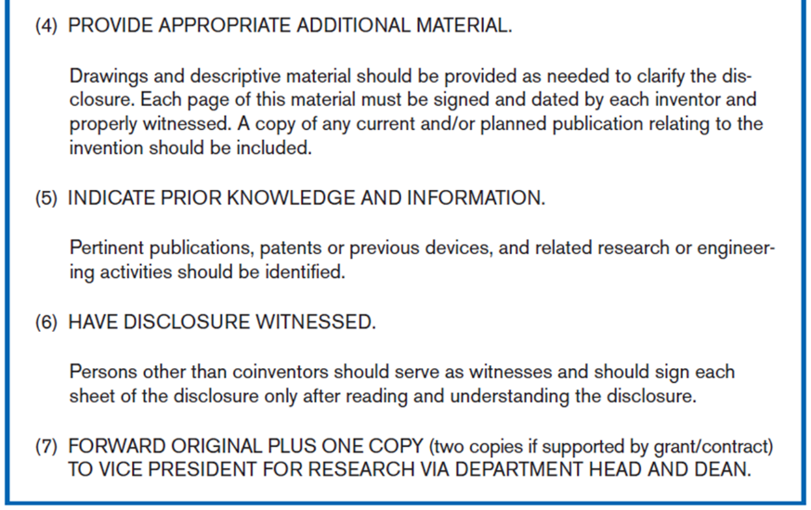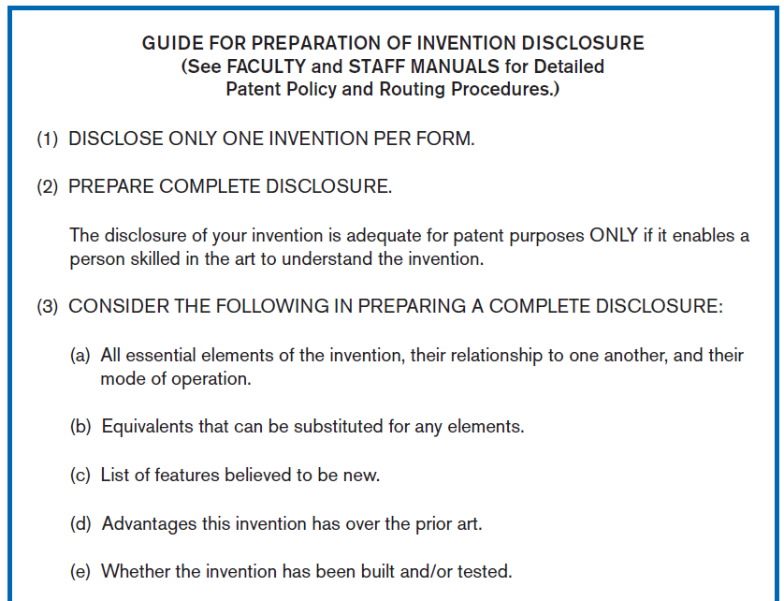Includes data and information used and created in the process
* Potential Problems with Procedure Documents:
* May involve duplication of effort
* May have missing procedures
* May be out of date
* May contradict information obtained through interviews
* The aforementioned problems illustrate the difference between formal systems and informal systems
  + **Formal Systems**: the official way a system works as described in organizational documentation (i.e. work procedure)
  + **Informal Systems**: the way a system actually works (i.e. interviews, observations)
* **Useful document: Business form**
  + Used for all types of business functions
  + Explicitly indicates what data flow in and out of a system and data necessary for the system to function
  + 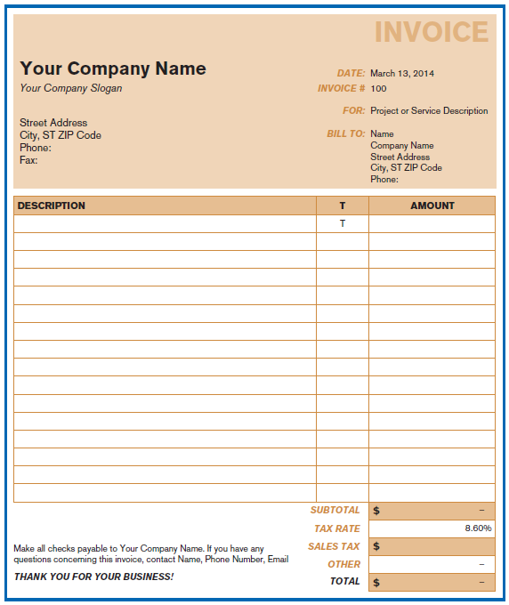Gives crucial information about the nature of the organization
* **Useful document: Report**
  + Primary output of current system
  + Enables you to work backwards from the report to the 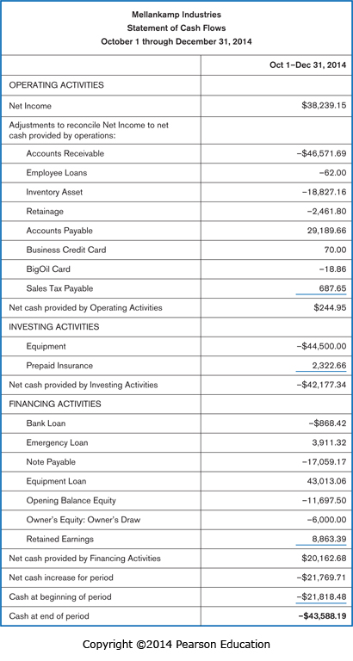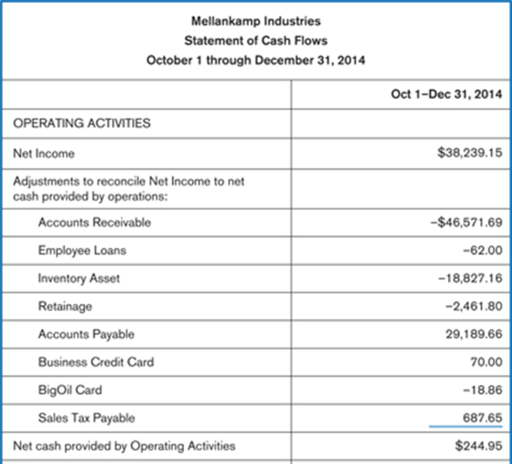data needed to generate it
* 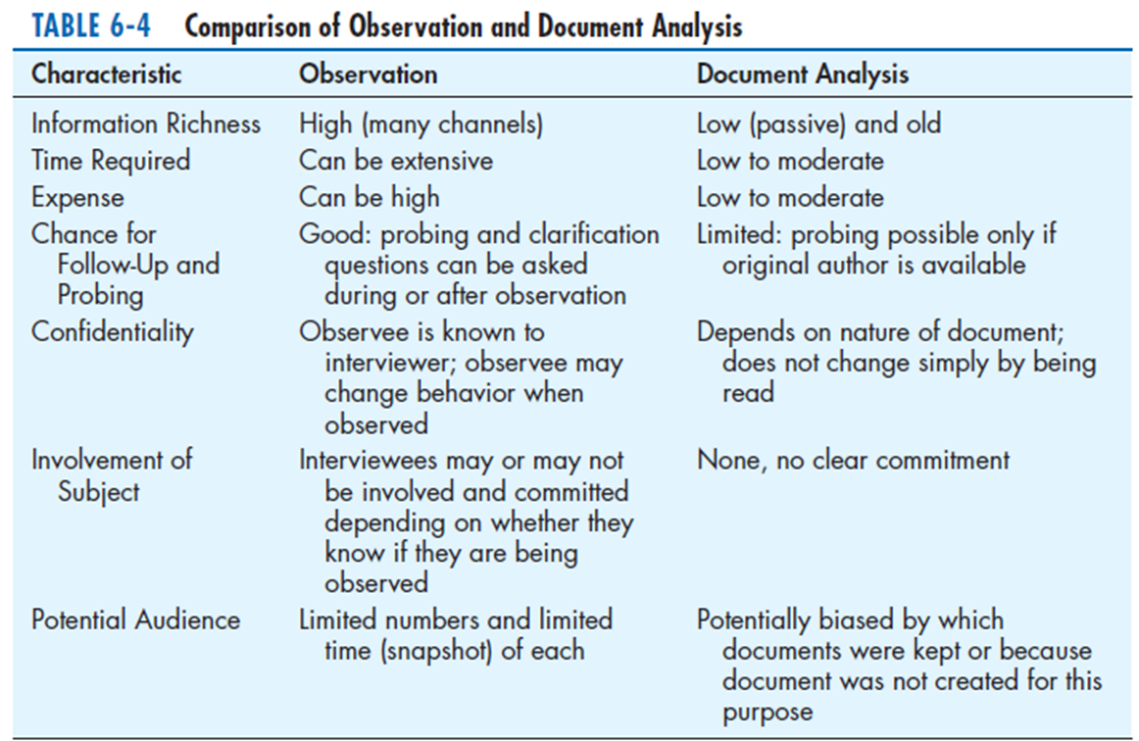**Useful document: Description of current information system**

1. **Contemporary Methods for Determining System Requirements**
   * **Joint Application Design (JAD)**

* Brings together key users, managers, and systems analysts
* Purpose: collect system requirements simultaneously from key people
* Conducted off-site
* JAD Participants:
  + **Session Leader:** facilitates group process
  + **Users**: active, speaking participants
  + **Managers**: active, speaking participants
  + **Sponsor**: high-level champion, limited participation
  + **Systems Analysts**: should mostly listen
  + **Scribe**: record session activities
  + **IS Staff**: should mostly listen
* End Result
  + Documentation detailing existing system
  + Features of proposed system
  + **CASE tools to support JAD**
* Used to analyze existing systems
* Help discover requirements to meet changing business conditions
* Upper CASE tools are used
* Enables analysts to enter system models directly into CASE during the JAD session
* The most useful
  + For diagramming
  + For form and report generation
* Menu, screen, and report designs and prototyping can be done during JAD and shown to users
  + **System prototypes**
* Iterative development process
* Rudimentary working version of system is built
* Refine understanding of system requirements in concrete terms

1. **Using Prototyping During Requirements Determination**
   * Quickly converts requirements to working version of system
   * Once users see requirements converted to system, they will ask for modifications or will generate additional requests

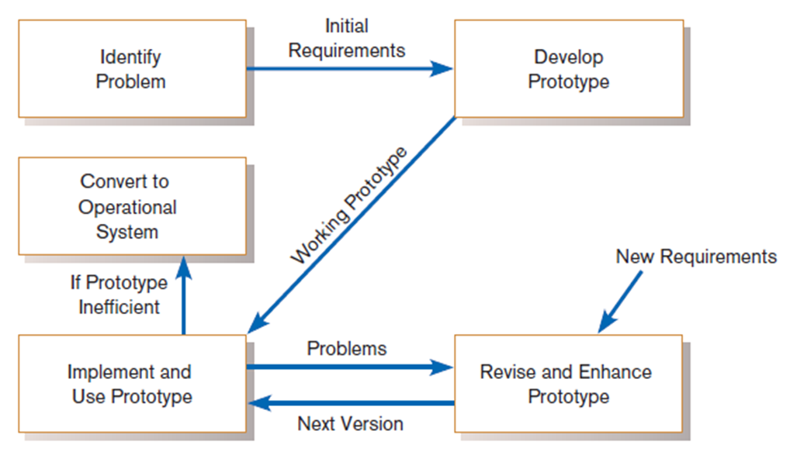

* Evolutionary prototyping
  + The prototype can then serve as the basis for the production system
  + Prototype becomes the actual production system
  + 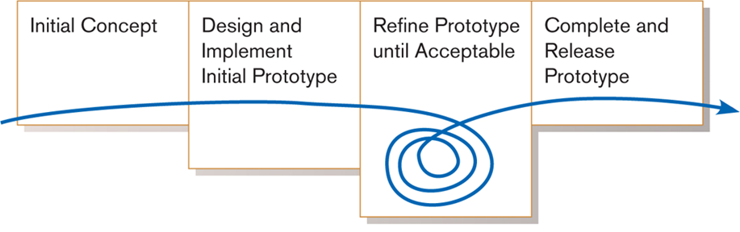Often starts with those parts of the system that are most difficult and uncertain
* Throwaway prototyping
  + The prototype can serve only as a model, which is then used as a reference for the construction of the actual system
  + Developed quickly to demonstrate some aspect of a system design that is unclear or to help users decide among different features or interface characteristics
* Most useful when:
  + User requests are not clear.
  + Few users are involved in the system.
  + Designs are complex and require concrete form.
  + There is a history of communication problems between analysts and users.
  + Tools are readily available to build prototype.
* Drawbacks
  + Tendency to avoid formal documentation
  + Difficult to adapt to more general user audience
  + Sharing data with other systems is often not considered
  + Systems Development Life Cycle (SDLC) checks are often bypassed

1. **Radical Methods for Determining System Requirements**
   * Business Process Reengineering (BPR)**:** search for and implementation of radical change in business processes to achieve breakthrough improvements in products and services

* Creatively using IT can yield significant improvements in most business processes
  + Goals of BPR (In a system modeling sense)
* Reorganize complete flow of data in major sections of an organization.
* Eliminate unnecessary steps.
* Combine steps.
* Become more responsive to future change.
  + Key business processes
* Structured, measured set of activities designed to produce specific output for a particular customer or market
* Focused on customers and some type of organizational outcome
* Same techniques as requirements determination are used
  + Identify specific activities that can be radically improved through BPR
* How important is the activity to deliver an outcome
* How feasible is changing the activity
* How dysfunctional is the activity
  + Many of the tools and techniques for modeling data, processes, events, and logic within the IS development process are also being applies to model business process with BPR efforts

1. **Disruptive Technologies**
   * Information technologies must be applied to radically improve business processes.

* Think “inductively” about IT
* Managers must learn the power of new technologies and think innovative ways to alter the way work is done
* To apply disruptive technologies when applying inductive thinking
  + 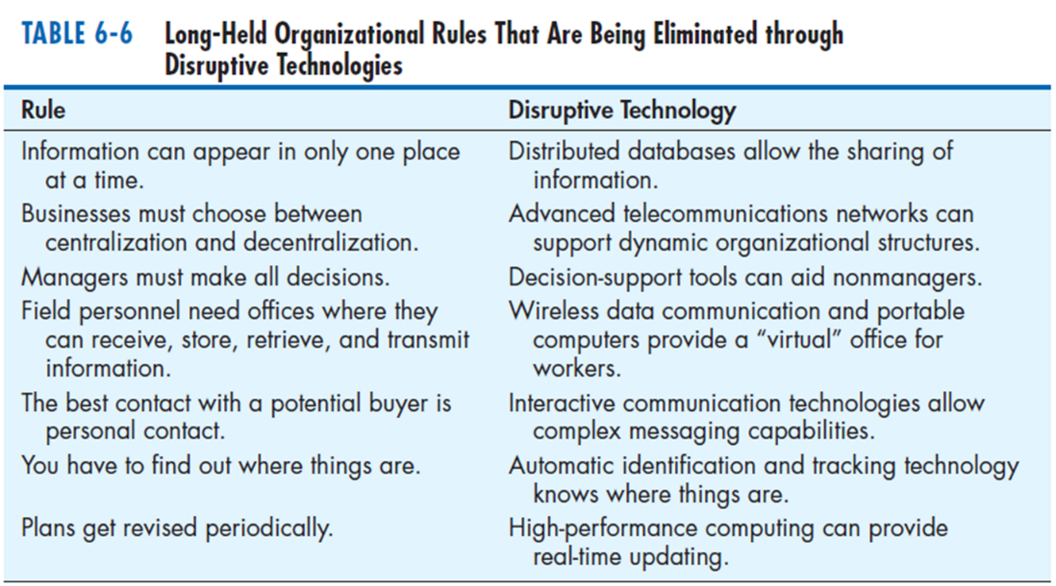Disruptive technologies are technologies that enable the breaking of long-held business rules that inhibit organizations from making radical business changes.

1. **Requirements Determination using Agile Methodologies**
   * Continual user involvement

* SDLC waterfall allowed users to be involved in the development process only in the early stages of analysis
* Replace traditional SDLC waterfall with iterative analyze–design–code–test cycle favored by the Agile and RAD Methodologies
* Work best when development team is small and dedicated

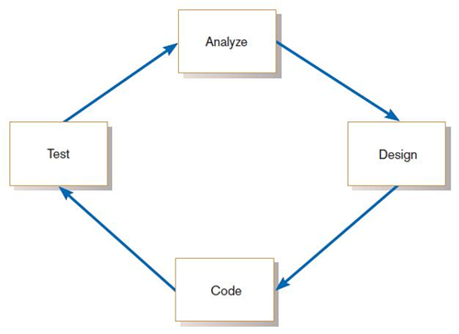

* + Agile usage-centered design
* Compared with JAD, Agile Usage-Centered Design focuses on user goals, roles, and tasks

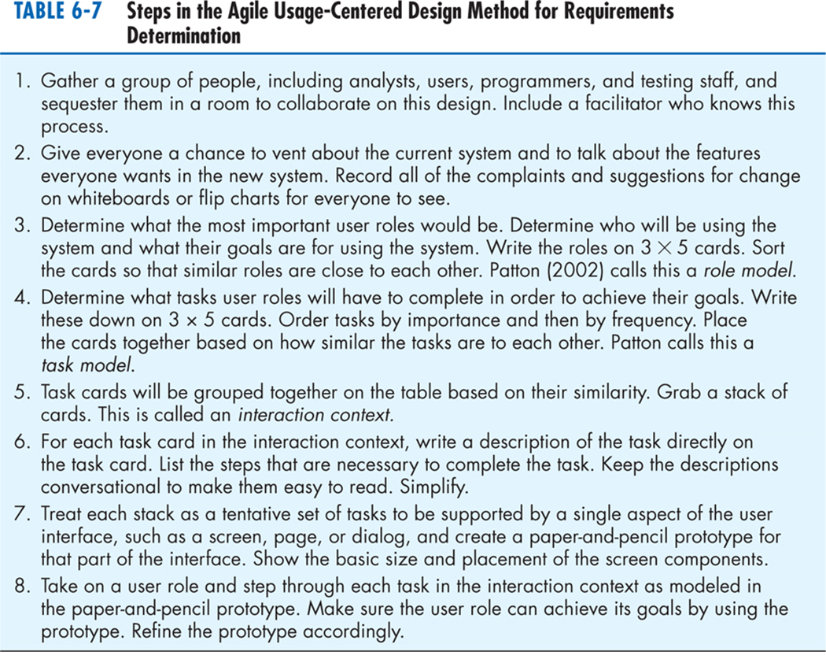

* + The Planning Game
* Based on eXtreme programming
* A stylized approach to development that seeks to maximize fruitful interaction between those who need a new system and those who build it
* The players in the Planning Game: **Business** and Development
* The game pieces: **Story Cards** created by **Business**
* Three phases: **exploration, commitment, steering**

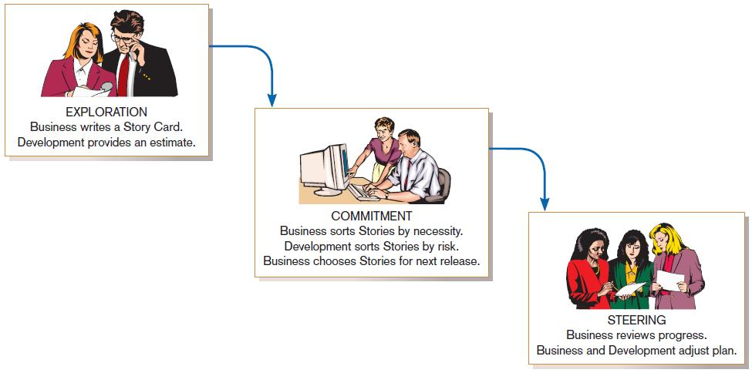

* + **The Interaction Planning Game**
* Take place during the time intervals between steering phase meeting in the Planning Game
* Played only by programmers
* Programmers write **Task Cards**, which are based on **Story Cards**
* Has the came three phases
  + Exploration: convert Story Cards into Task Cards
  + Commitment: accept responsibility for tasks and balance their workloads
  + Steering: write the code for the feature, test it, and if it works, integrate the feature into the procedure being developed

1. **Electronic Commerce Applications: Determining System Requirements**
   * Determining system requirements for Pine Valley furniture’s WebStore

* System layout and navigation characteristics
* WebStore and site management system capabilities
* Customer and inventory information
* System prototype evolution